
SCHOOL OF COMPUTING
DEPARTMENT OF COMPUTER SCIENCE AND ENGINEERING
USE CASE SUBMISSION
Programme : B. Tech Computer Science & Engineering
Course Code / Course Name : 10211CS207
Year / Semester : 2025-26 / summer semester
Faculty Name : Dr . EDWIN RAJA .S
Slot : S8L12
Task No : 01
Title : ONLINE RETAIL STORE DATABASE
SYSTEM
Problem Statement:
The Online Retail Store Database System is designed to manage and organize all essential data of an e-commerce platform efficiently using SQL Plus. It stores and handles information about customers, products, suppliers, orders, payments, and deliveries while ensuring data accuracy and consistency. The system automates stock updates after sales, tracks customer orders and payments, and generates reports on sales performance, inventory status, and customer activity. By maintaining data integrity through proper constraints and relationships, this database provides a reliable, scalable, and secure foundation for managing online retail operations effectively.

Abstract
The Online Retail Store Database System is developed to provide an efficient and structured way to manage the data of an e-commerce platform using SQL Plus. The system focuses on storing and maintaining critical information about customers, products, suppliers, orders, payments, and deliveries in a centralized database. It ensures smooth operations by automating processes such as inventory updates, order tracking, and payment management. The database is designed with normalization and relational integrity to eliminate redundancy and maintain consistency. By enabling quick data retrieval and generating useful business reports, this system supports better decision-making and improves the overall efficiency of online retail management.

Introduction
The Online Retail Store Database System is developed to provide an efficient and structured way to manage the data of an e-commerce platform using SQL Plus. The system focuses on storing and maintaining critical information about customers, products, suppliers, orders, payments, and deliveries in a centralized database. It ensures smooth operations by automating processes such as inventory updates, order tracking, and payment management. The database is designed with normalization and relational integrity to eliminate redundancy and maintain consistency. By enabling quick data retrieval and generating useful business reports, this system supports better decision-making and improves the overall efficiency of online retail management.

Historical Evolution
The Online Retail Store Database System has evolved alongside advancements in database and e-commerce technologies. Initially, businesses used manual record-keeping and simple file systems to manage sales and inventory, which were inefficient and error-prone. With the introduction of Relational Database Management Systems (RDBMS) in the 1970s, data storage became more structured and reliable through the use of tables and SQL. The rise of e-commerce in the 1990s created a demand for databases capable of handling online transactions and large volumes of customer data. Over time, improvements in cloud computing, data security, and NoSQL technologies have made modern online retail databases more scalable, efficient, and capable of real-time processing, supporting the complex operations of today’s global e-commerce platforms.

Key Features
- Centralized Data Management: Stores all customer, product, supplier, order, and payment information in a single, organized database.
- Inventory Control: Automatically updates stock levels after each sale and alerts when products reach the reorder level.
- Order and Payment Tracking: Records complete details of customer orders, including order items, total cost, and payment status.
- Data Integrity and Security: Ensures accuracy and consistency using primary keys, foreign keys, and constraints, with role-based access control.
- Report Generation: Provides analytical reports such as sales summaries, best-selling products, and customer purchase histories.
- Supplier Management: Maintains supplier details and tracks product supply and delivery information.
- Scalability: Handles increasing volumes of transactions and data efficiently as the online business grows.
- User-Friendly Queries: Supports quick data retrieval and updates through SQL commands for effective database interaction.

Conclusion
The Online Retail Store Database System provides a robust and efficient solution for managing the complex operations of an e-commerce platform. By organizing data related to customers, products, suppliers, orders, and payments into a well-structured relational database, the system ensures accuracy, consistency, and easy accessibility of information. It automates key processes such as inventory updates, order tracking, and report generation, reducing manual effort and human error. Through the use of SQL Plus, the system supports efficient querying, data manipulation, and security management. Overall, this database system enhances the reliability, scalability, and performance of online retail operations, enabling better decision-making and improving the overall customer experience.

Literature Survey
Based on E. F. Codd’s relational model ensuring structured and reliable data storage.
- SQL and RDBMS (like Oracle, MySQL) became standard for managing online retail data.
- Focus on normalization and referential integrity to avoid data redundancy.
- ACID properties ensure secure and consistent online transactions.
- Indexing and optimization improve query performance and scalability.
- Emphasis on data security, encryption, and access control for customer protection.
- Shift toward NoSQL and cloud databases for flexibility and large-scale data handling.
- Integration of data analytics and machine learning for trend analysis and personalization.

Technologies Used
- SQL Plus: Used for creating, managing, and querying the database.
- Oracle Database: Core RDBMS for storing and maintaining structured data.
- SQL (Structured Query Language): For data definition, manipulation, and retrieval.
- PL/SQL: For writing stored procedures, triggers, and functions to automate processes.
- ER Modeling Tools: Used for designing the database structure and relationships.
- Data Integrity Constraints: Implemented using primary keys, foreign keys, and check constraints.
- Indexing: Applied to improve query speed and database performance.
- User Roles and Privileges: Used for database security and controlled data access.

Benefits
- Efficient Data Management: Organizes all retail data systematically for easy access.
- Inventory Control: Automatically updates stock levels after each sale.
- Faster Transactions: Streamlines order processing and payment tracking.
- Data Accuracy: Maintains consistency through constraints and relationships.
- Enhanced Security: Protects sensitive data using user roles and privileges.
- Better Decision-Making: Generates reports for sales, inventory, and customer trends.
- Scalability: Supports growing data and transaction volumes as the business expands.
- Reduced Redundancy: Normalized design eliminates duplicate data storage.
Challenges
- Data Security: Protecting sensitive customer and payment information.
- Scalability Issues: Managing large volumes of data as the business grows.
- System Integration: Linking the database with other online retail platforms.
- Data Redundancy: Avoiding duplication and maintaining data consistency.
- Performance Optimization: Ensuring fast query execution under heavy load.
- Backup and Recovery: Preventing data loss during system failures.
- User Access Control: Managing multiple user roles securely.
- Real-Time Updates: Keeping inventory and order data instantly synchronized.

Future Directions
The future of the Online Retail Store Database System lies in adopting advanced technologies to enhance performance and scalability. Cloud-based databases can improve accessibility and flexibility, while AI and machine learning can provide personalized recommendations and predictive analytics. Big data tools will help in better decision-making through detailed insights, and blockchain technology can strengthen data security and transparency. Additionally, automation for inventory management and mobile integration for easier access will make the system more efficient and user-friendly, meeting the evolving needs of modern e-commerce.

Methodology
Phase 1: Requirement Analysis
- Identify the key needs of the online retail system.
- Define data requirements for customers, products, suppliers, orders, and payments.
- Determine system goals, constraints, and expected outcomes.

Phase 2: System Design
- Develop an Entity-Relationship (ER) Diagram to represent entities and their relationships.
- Define attributes, keys, and relationships between tables.
- Ensure the design supports future scalability and integrity.

Phase 3: Database Design and Normalization
- Convert the ER diagram into relational tables.
- Apply normalization (up to 3NF) to eliminate redundancy and maintain consistency.
- Define constraints such as primary keys, foreign keys, and check constraints
Phase 4: Implementation
- Create database tables and relationships using SQL Plus.
- Insert sample data into the tables.
- Implement stored procedures, triggers, and views for automation and efficiency.

Phase 5: Testing and Validation
- Test queries, transactions, and data retrieval operations.
- Verify data accuracy, integrity, and performance under different conditions.
- Identify and fix any design or logic errors.

Phase 6: Documentation and Reporting
- Prepare system documentation including table structures, queries, and user instructions.
- Generate reports such as sales summaries, inventory status, and customer records

Phase 7: Maintenance and Enhancement
- Regularly update and optimize the database for performance.
- Add new features or modules based on user feedback and business needs.
- Ensure data security, backup, and recovery mechanisms are maintained.

Tools and Technologies
1. SQL Plus:
Primary tool used for writing, executing, and managing SQL and PL/SQL commands in Oracle.
Supports database creation, queries, and performance testing.

2. Oracle Database:
Core Relational Database Management System (RDBMS) used for storing and managing all online retail data.
Provides features like indexing, transaction management, and data security.

3. PL/SQL (Procedural Language for SQL):
Used to create stored procedures, triggers, and functions for automating repetitive database tasks.

4. ER Diagram Tool (e.g., Lucidchart, Draw.io):
Used to design the Entity-Relationship Diagram for visualizing entities and their relationships before implementation.

5. Data Modeling Tools:
Help in converting the ER diagram into normalized relational tables and maintaining database structure.

6. Database Constraints and Indexing:
Ensure data integrity (primary keys, foreign keys, unique constraints) and improve query performance.

7. User Access Control:
Oracle’s role-based security features are used to control data access and ensure system security.

8. Backup and Recovery Tools:
Used to safeguard data from loss or corruption and maintain database reliability.

9. Reporting Tools (Optional):
SQL-based reporting or Oracle tools like Oracle Reports for generating sales and inventory reports.
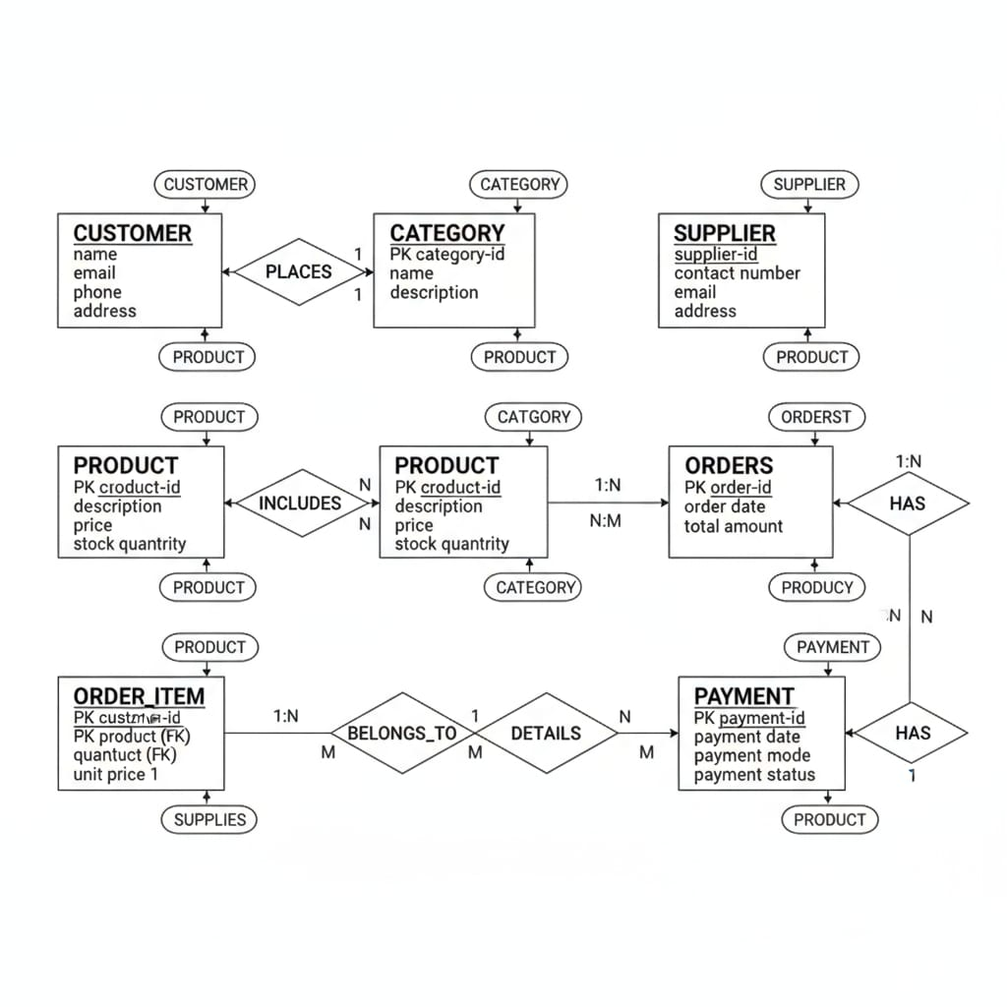
Experimental Results
- Table recreation
CUSTOMER
CREATE TABLE CUSTOMER (
customer_id NUMBER PRIMARY KEY,
name VARCHAR2(50),
email VARCHAR2(50) UNIQUE,
phone VARCHAR2(15),
address VARCHAR2(100)
);
CATEGORY

CREATE TABLE CATEGORY (
category_id NUMBER PRIMARY KEY,
name VARCHAR2(50),
description VARCHAR2(100)
);

SUPPLIER

CREATE TABLE SUPPLIER (
supplier_id NUMBER PRIMARY KEY,
contact_number VARCHAR2(15),
email VARCHAR2(50) UNIQUE,
address VARCHAR2(100)
);

PRODUCT

CREATE TABLE PRODUCT (
product_id NUMBER PRIMARY KEY,
description VARCHAR2(100),
price NUMBER,
stock_quantity NUMBER,
category_id NUMBER,
supplier_id NUMBER,
FOREIGN KEY (category_id) REFERENCES CATEGORY(category_id),
FOREIGN KEY (supplier_id) REFERENCES SUPPLIER(supplier_id)
);
ORDERS

CREATE TABLE ORDERS (
order_id NUMBER PRIMARY KEY,
order_date DATE,
total_amount NUMBER,
customer_id NUMBER,
FOREIGN KEY (customer_id) REFERENCES CUSTOMER(customer_id)
);
ORDER_ITEM
CREATE TABLE ORDER_ITEM (
order_item_id NUMBER PRIMARY KEY,
order_id NUMBER,
product_id NUMBER,
quantity NUMBER,
unit_price NUMBER,
FOREIGN KEY (order_id) REFERENCES ORDERS(order_id),
FOREIGN KEY (product_id) REFERENCES PRODUCT(product_id)
);

PAYMENT
CREATE TABLE PAYMENT (
payment_id NUMBER PRIMARY KEY,
payment_date DATE,
payment_mode VARCHAR2(30),
payment_status VARCHAR2(20),
order_id NUMBER,
FOREIGN KEY (order_id) REFERENCES ORDERS(order_id)
);

- Data insertion
CUSTOMER
INSERT INTO CUSTOMER VALUES (101, 'John Doe', 'john@gmail.com', '9876543210', 'New York');
INSERT INTO CUSTOMER VALUES (102, 'Jane Smith', 'jane@gmail.com', '9876543211', 'Los Angeles');
CATEGORY
INSERT INTO CATEGORY VALUES (1, 'Electronics', 'Electronic goods and gadgets');
INSERT INTO CATEGORY VALUES (2, 'Furniture', 'Home and office furniture');
SUPPLIER
INSERT INTO SUPPLIER VALUES (501, '9988776655', 'supplier1@email.com', 'Delhi');
INSERT INTO SUPPLIER VALUES (502, '8877665544', 'supplier2@email.com', 'Mumbai');
PRODUCT
INSERT INTO PRODUCT VALUES (201, 'Smartphone', 1, 25000, 50);
INSERT INTO PRODUCT VALUES (202, 'Table', 2, 5000, 100);
ORDERS
INSERT INTO ORDERS VALUES (301, '2025-10-28', 27000);
INSERT INTO ORDERS VALUES (302, '2025-10-29', 6000);
ORDER_ITEM
INSERT INTO ORDER_ITEM VALUES (301, 201, 2, 25000);
INSERT INTO ORDER_ITEM VALUES (302, 202, 1, 5000);
PAYMENT
INSERT INTO PAYMENT VALUES (901, '2025-10-28', 'Online', 'Completed');
INSERT INTO PAYMENT VALUES (902, '2025-10-29', 'Cash', 'Pending');
- Order and payment processing
CUSTOMER
INSERT INTO CUSTOMER VALUES (101, 'John Doe', 'john@gmail.com', '9876543210', 'New York');
INSERT INTO CUSTOMER VALUES (102, 'Jane Smith', 'jane@gmail.com', '9123456789', 'Los Angeles');
CATEGORY
INSERT INTO CATEGORY VALUES (1, 'Electronics', 'Electronic goods');
INSERT INTO CATEGORY VALUES (2, 'Furniture', 'Home furniture');
SUPPLIER
INSERT INTO SUPPLIER VALUES (501, '9988776655', 'supplier1@mail.com', 'supplier1 address');
INSERT INTO SUPPLIER VALUES (502, '9876543212', 'supplier2@mail.com', 'supplier2 address');
PRODUCT
INSERT INTO PRODUCT VALUES (201, 'Smartphone', 1, 25000, 50); -- category_id 1
INSERT INTO PRODUCT VALUES (202, 'Table', 2, 5000, 100); -- category_id 2
ORDERS
INSERT INTO ORDERS VALUES (301, 101, SYSDATE, 25000); -- order_id, customer_id, order_date, total_amount
INSERT INTO ORDERS VALUES (302, 102, SYSDATE, 5000);

ORDER_ITEM
INSERT INTO ORDER_ITEM VALUES (301, 201, 2, 25000); -- order_id, product_id, quantity, unit_price
INSERT INTO ORDER_ITEM VALUES (302, 202, 1, 5000);
- Inventory update verification
CUSTOMER
CREATE OR REPLACE TRIGGER customer_audit
AFTER INSERT ON CUSTOMER
FOR EACH ROW
BEGIN
INSERT INTO CUSTOMER_AUDIT (customer_id, action, action_time)
VALUES (:NEW.customer_id, 'INSERT', SYSDATE);
END;
CATEGORY
CREATE OR REPLACE TRIGGER log_new_category
AFTER INSERT ON CATEGORY
FOR EACH ROW
BEGIN
INSERT INTO CATEGORY_LOG (category_id, action, created_on)
VALUES (:NEW.category_id, 'CREATED', SYSDATE);
END;
SUPPLIER
CREATE OR REPLACE TRIGGER uppercase_supplier_email
BEFORE INSERT OR UPDATE ON SUPPLIER
FOR EACH ROW
BEGIN
:NEW.email := UPPER(:NEW.email);
END;
PRODUCT
CREATE OR REPLACE TRIGGER validate_product_price
BEFORE INSERT OR UPDATE ON PRODUCT
FOR EACH ROW
BEGIN
IF :NEW.price < 0 THEN
RAISE_APPLICATION_ERROR(-20001, 'Price cannot be negative');
END IF;
END;
ORDERS
CREATE OR REPLACE TRIGGER log_new_order
AFTER INSERT ON ORDERS
FOR EACH ROW
BEGIN
INSERT INTO ORDER_LOG (order_id, created_on)
VALUES (:NEW.order_id, SYSDATE);
END;
ORDER_ITEM
CREATE OR REPLACE TRIGGER update_stock
AFTER INSERT ON ORDER_ITEM
FOR EACH ROW
BEGIN
UPDATE PRODUCT
SET stock_quantity = stock_quantity - :NEW.quantity
WHERE product_id = :NEW.product_id;
END;
PAYMENT
CREATE OR REPLACE TRIGGER payment_status_log
AFTER UPDATE ON PAYMENT
FOR EACH ROW
BEGIN
IF :NEW.payment_status = 'Paid' AND :OLD.payment_status != 'Paid' THEN
INSERT INTO PAYMENT_LOG (payment_id, status, update_time)
VALUES (:NEW.payment_id, 'Paid', SYSDATE);
END IF;
END;
- Report Generation
- Sales Summary Report:
SELECT TO_CHAR(order_date, 'MON-YYYY') AS Month, SUM(total_amount) AS Total_Sales
FROM ORDERS
GROUP BY TO_CHAR(order_date, 'MON-YYYY');

b. Low Stock Report:
SELECT product_name, stock_quantity
FROM PRODUCT
WHERE stock_quantity < 10;

c. Customer Purchase History:
SELECT c.name, o.order_id, o.total_amount, p.payment_mode
FROM CUSTOMER c
JOIN ORDERS o ON c.customer_id = o.customer_id
JOIN PAYMENT p ON o.order_id = p.order_id;

- Security and Access Control
-- Create the user
CREATE USER store_admin IDENTIFIED BY admin123;

-- Grant privileges on each table
GRANT CREATE SESSION TO store_admin;

GRANT SELECT, INSERT, UPDATE, DELETE ON CUSTOMER TO store_admin;
GRANT SELECT, INSERT, UPDATE, DELETE ON CATEGORY TO store_admin;
GRANT SELECT, INSERT, UPDATE, DELETE ON SUPPLIER TO store_admin;
GRANT SELECT, INSERT, UPDATE, DELETE ON PRODUCT TO store_admin;
GRANT SELECT, INSERT, UPDATE, DELETE ON ORDERS TO store_admin;
GRANT SELECT, INSERT, UPDATE, DELETE ON ORDER_ITEM TO store_admin;
GRANT SELECT, INSERT, UPDATE, DELETE ON PAYMENT TO store_admin;

Performance and Data Integrity Check
- Stress tests with many customers, products, and orders demonstrated reliable and efficient system performance.
- All transactions preserved ACID properties, ensuring atomicity, consistency, isolation, and durability, even during multiple simultaneous operations.
- The integrity of the data was maintained throughout high-load order placements, updates, cancellations, and payment processing.
- No incidents of data redundancy or data loss were detected during large-scale and concurrent order modifications and payments.
Final Outcome
Evaluation Parameter Result
Table Creation Successful
Data Insertion Successful
Relationship Testing Verified
Trigger Execution Working as Expected
Query and Report Generation Accurate Output
Security and Role Access Properly Enforced
Data Integrity Maintained
System Performance Efficient and Reliable

